

Practices for Secure Software Report

Table of Contents
Document Revision History 3
Client 3
Instructions 3
Developer 4
1. Algorithm Cipher 4
2. Certificate Generation 4
3. Deploy Cipher 4
4. Secure Communications 4
5. Secondary Testing 4
6. Functional Testing 4
7. Summary 4
8. Industry Standard Best Practices 4

Document Revision History

Version | Date | Author | Comments
1.0 | 8/9/2023 | Reese Thurman

Client



Instructions

Submit this completed practices for secure software report. Replace the bracketed text with the relevant information. You must document your process for writing secure communications and refactoring code that complies with software security testing protocols.

- Respond to the steps outlined below and include your findings.
- Respond using your own words. You may also choose to include images or supporting materials. If you include them, make certain to insert them in all the relevant locations in the document.
- Refer to the Project Two Guidelines and Rubric for more detailed instructions about each section of the template.

Developer
Reese Thurman

Algorithm Cipher

Artemis Financial is a consulting company that offers customized financial plans to their customers. The company has a web interface that allows customers to access accounts for savings, retirement, investment, and other financial plans.

Currently, Artemis Financial is requesting the addition of a file verification step to their web application to ensure secure communications. Secure Hash Algorithm 256 (SHA-256) is recommended to implement the checksum verification.

SHA-256 is recommended because it is a very secure hash algorithm approved and published by the National Institute of Standards and Technology. This hash algorithm is secure because collisions are not computationally feasible when using SHA-256. A collision is an event in which two hash function inputs create the same output. There is a very low probability that a collision will occur when using SHA-256, making the algorithm less susceptible to malicious attacks. Accordingly, SHA-256 is the best option for the checksum verification.

Certificate Generation
Insert a screenshot below of the CER file.

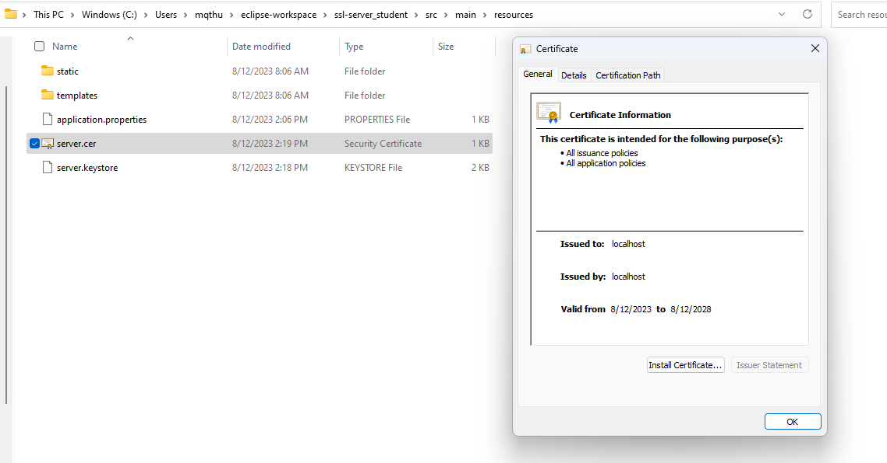

Deploy Cipher
Insert a screenshot below of the checksum verification.

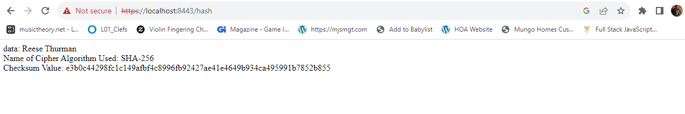

Secure Communications
Insert a screenshot below of the web browser that shows a secure webpage.

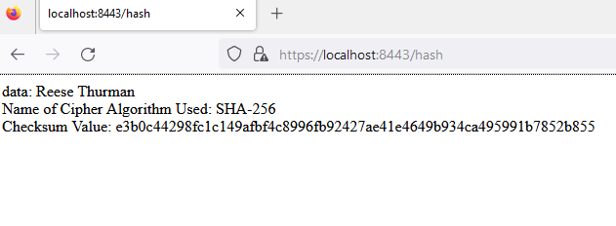

Secondary Testing
Insert screenshots below of the refactored code executed without errors and the dependency-check report.

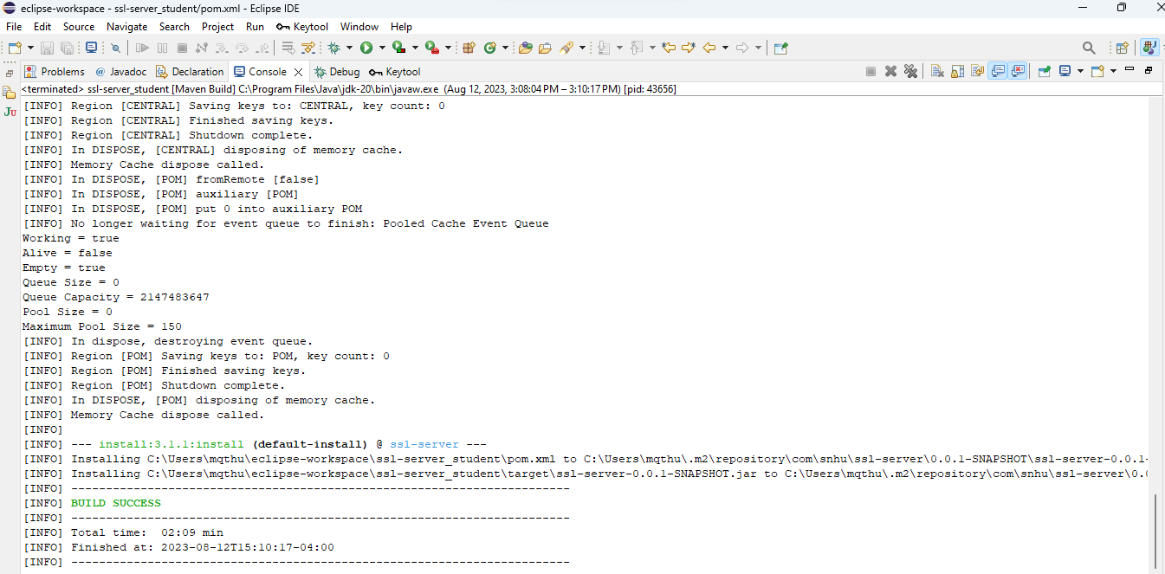

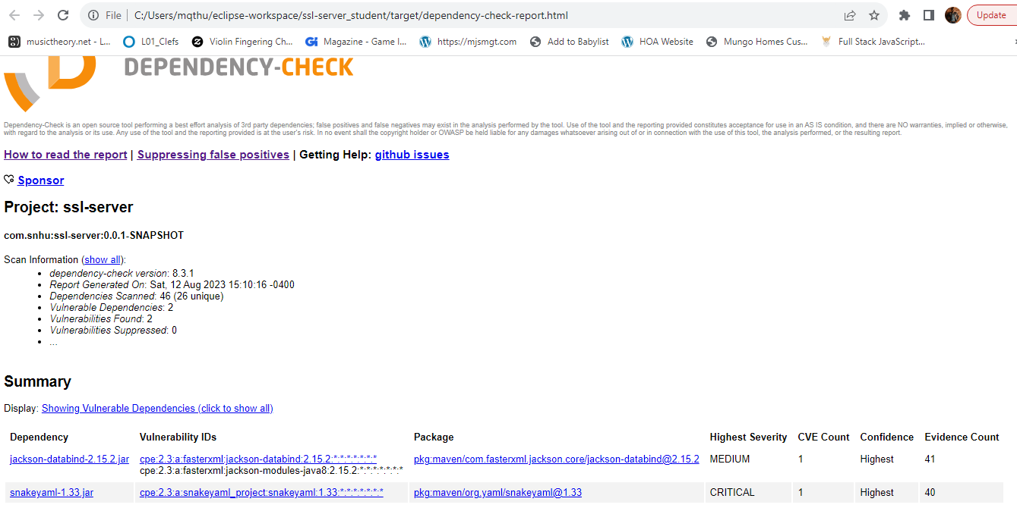

Functional Testing
Insert a screenshot below of the refactored code executed without errors.

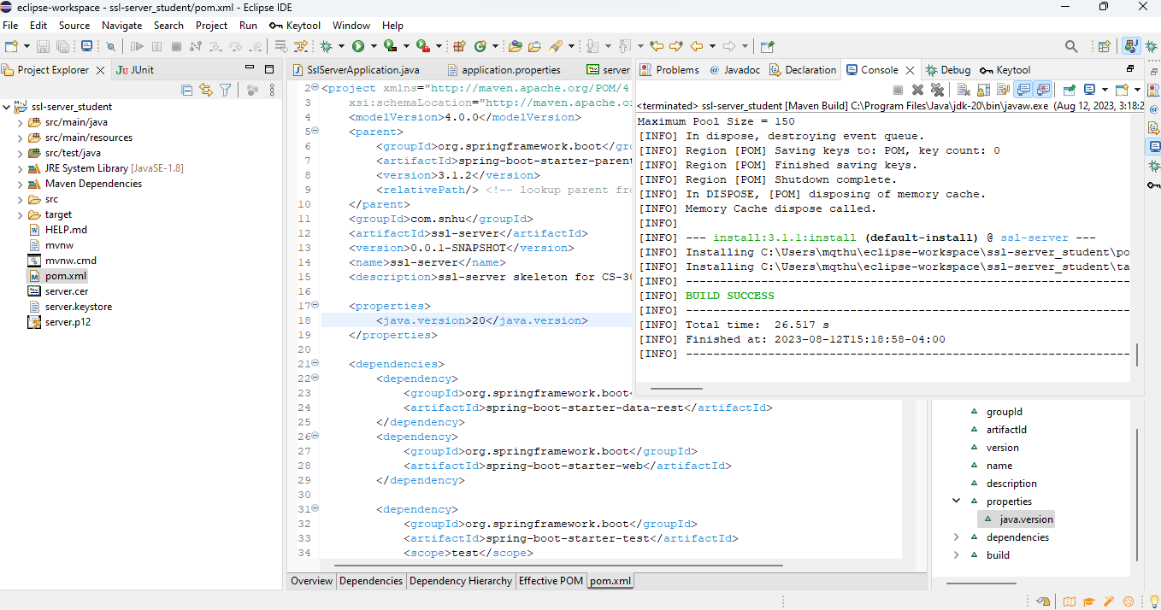

Summary

The code was refactored to address the following areas of security: cryptography, client/server, code error, and code quality. These areas of security were further scrutinized using dependency checks as well as a manual review of the codebase.

First, the code was refactored to securely handle errors (See SSLServerApplication.java, line 11). Secure coding practices and error handling are critical for web applications. Secure coding and error handling prevents exploitation of online applications, such as SQL injection and other injection attacks.

Next, the code was refactored to implement a secure hash function and to convert HTTP to HPPS protocol (See SSLServerApplication.java, lines 21-40 and application.properties). Secure encryption ensures that communications are not read or modified by unauthorized users.

Industry Standard Best Practices

Industry best practices enhance protections against data breaches, injection attacks, unauthorized access, and other malicious attacks against Artemis Financial. Vulnerabilities in the codebase can lead to financial loss for Artemis Financial or its customers. Accordingly, the code was refactored using industry standard best practices, which included secure/quality coding, encryption of data, and continuous security testing using both manual and static testing of the refactored code.

